Recursive Trees
Recursive trees are geometric pictures (made using a recursive process) that look like trees. The following are examples of one such process with different levels of recursion:
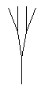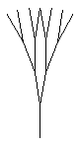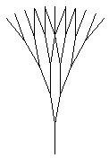
n=2 n=3 n=4 n=5
Your assignment is to write a recursive tree program. The recursive method itself should be called branch. It can be declared as follows:
public void branch(Graphics g, int x, int y, int length,
int angle, int angleChange, int num)

Where: x and y are the coordinates of the start of a branch
length is the length of a branch
angle is the angle of the branch (in degrees)
angleChange is the change in angle for the next branches
num is the level of recursion

You can calculate the endpoints of a branch from the following formula:
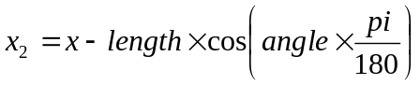
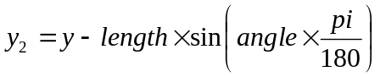
If each branch has two branches from it, you will want two recursive calls to branch()
- Both will be passed the endpoint of the previous branch (x2 and y2) as their starting points.
- Their length and angleChange will be the same as the previous branch.
- They must both be passed num-1 as their level of recursion.
- One will have an angle of angle-angleChange.
- One will have an angle of angle+angleChange.

Hints: ➢ You will need Math.PI, Math.cos(), and Math.sin()
- Make sure you do not call the method again when num=0

Bonus: Let the user change the number of branches, angleChange, etc.
Make each branch a fraction of the length of the previous (e.g. 3/4)
Change the colour of each iteration
-- use num to calculate the colour.
-- use new Color(r, g, b) where r, g and b are from 0-255

